For Organiser’s use:
由籌辦機構填寫
Reference No.:
參考編號
Received Date:  收件日期 |  | Time:  時間
Handled by:
經手人

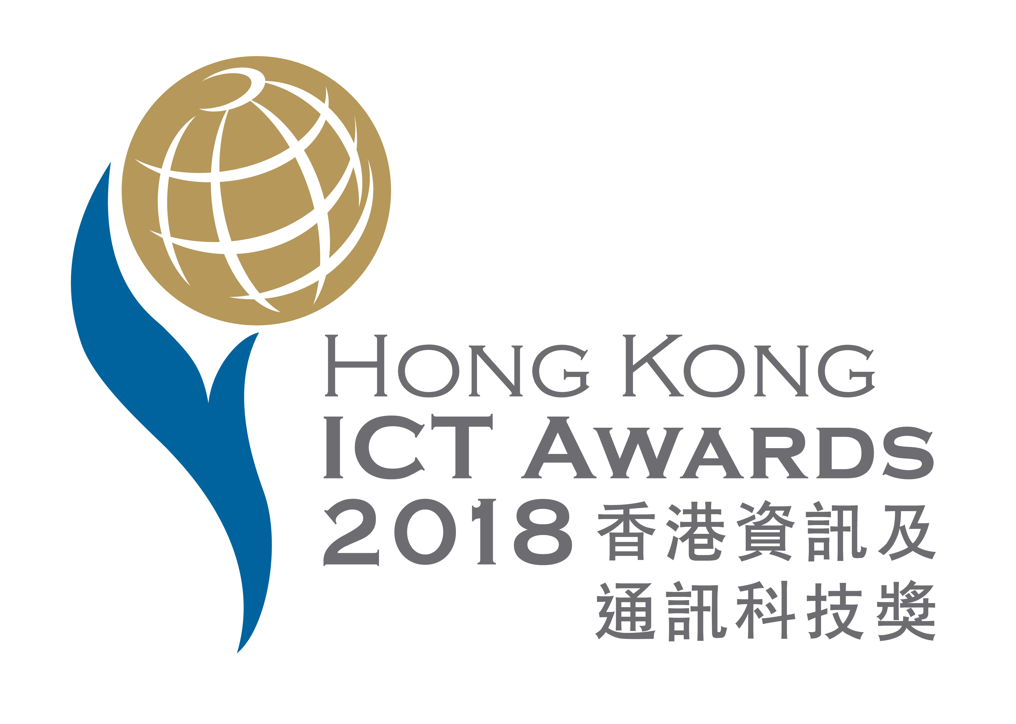

Smart Living Award
智慧生活獎
Application Form
申請表格

Entry Deadline: 12 January 2018 12:00 noon
截止申請時間: 二零一八年一月十二日中午十二時正

Entrant must submit with參賽機構須遞交以下資料:
- A hard-copy of the completed entry form in print AND email in WORD format to smartliving@hkitf.org.hk填妥的申請表格列印本一份，並電郵（文字檔案）到smartliving@hkitf.org.hk
- The form of declaration and indemnity in “Declaration” duly completed with authorised signature and company chop. 於“聲明”簽署已授權的簽名並蓋上公司印章
- A copy of the Business Registration of the entrant(s) or equivalent supporting document; 各參賽公司的商業登記證副本或相關証明文件
Remarks: All submitted information should be in typewriting and both in Chinese and English
備註： 參加表格必須以中文及英文電腦打稿填寫

Please submit applications to Secretariat Office of Smart Living Award:
遞交參賽資料至智慧生活獎秘書處:

“ Hong Kong ICT Awards 2018: Smart Living Award”  Attn: Ms. Annie Chan  IT and Business Process Division  Hong Kong Productivity Council  78 Tat Chee Avenue, Kowloon | 香港九龍塘達之路78號  香港生產力促進局  資訊科技及業務流程部 陳約延小姐 收  * 請註明『2018香港資訊及通訊科技獎：智慧生活獎』

Section 1甲部: Participating Stream參賽獎項組別

Please select the award stream to be considered請選擇有意參與之獎項組別:
- Hong Kong ICT Awards 2018: Smart Living Award - Smart Healthcare
2018香港資訊及通訊科技獎：智慧生活獎 (智慧醫療)
- Hong Kong ICT Awards 2018: Smart Living Award - Smart Home
2018香港資訊及通訊科技獎：智慧生活獎 (智能家居)
- Hong Kong ICT Awards 2018: Smart Living Award - Smart Lifestyle
2018香港資訊及通訊科技獎：智慧生活獎 (生活時尚)

Special Mention特別嘉許
Each applicant to any of the above streams can nominate its entry for the below special mention(s) (if applicable) 除了上述獎項組別外，大會更設立了特別嘉許，以表揚及鼓勵更多為提高銀髮長者生活質素或使用雲端計算、人工智能或創意教育而開發的應用程式或產品；凡參加上述任何奬項組別的參加者，均可提名作品競逐以下之特別嘉許（若適合）:
Special Mention for Silver Power樂活銀髮 特別嘉許:
To appreciate and encourage the IT development and adoption for betterment of aged people’s quality of life以表揚及鼓勵更多為提高銀髮長者生活質素而開發的應用程式或產品

Special Mention for Cloud Computing 雲端計算 特別嘉許
To appreciate and encourage the IT development and adoption for Cloud Computing以表揚及鼓勵使用雲端計算而開發的應用程式或產品

Special Mention for Artificial Intelligence 人工智能 特別嘉許
To appreciate and encourage the IT development and adoption for Artificial Intelligence以為表揚及鼓勵使用人工智能的開發的應用程式／產品

Special Mention for Innovative Education創意教育 特別嘉許
To appreciate and encourage the IT development and adoption on the learning and education aspect以為表揚及鼓勵使用創意教育的開發的應用程式／產品

Section 2乙部: Particulars of the Entrant參賽者資料

MAJOR CONTACT PERSON主要聯絡人
Name of Contact Person聯絡人姓名: | English：  中文：
Company Name公司名稱: | English：  中文：
Tel電話:
Mobile手提:
Email電郵:
Fax傳真:

GENERAL INFORMATION 參賽機構資料
Company 1參賽公司1
Company name公司名稱: | English：  中文：
Address地址:
URL公司網址:
Name of Chief Executive Officer行政總裁姓名:
Date of Incorporation公司成立日期:
Business Registration No.商業登記證號碼:
Nature of Business業務性質:
No. of Employees員工數目:
Name of Holding Company (if applicable):  上市公司名稱(如適用): | English：  中文：

Company 2 (For Joint Entrant, if applicable) 參賽公司2 (聯合參賽公司適用)
Company name公司名稱: | English：  中文：
Address地址:
URL公司網址:
Name of Chief Executive Officer行政總裁姓名:
Date of Incorporation公司成立日期:
Business Registration No.商業登記證號碼:
Nature of Business業務性質:
No. of Employees員工數目:
Name of Holding Company (if applicable):  上市公司名稱(如適用): | English：  中文：

Company 3 (For Joint Entrant, if applicable) 參賽公司3 (聯合參賽公司適用)
Company name公司名稱: | English：  中文：
Address地址:
URL公司網址:
Name of Chief Executive Officer行政總裁姓名:
Date of Incorporation公司成立日期:
Business Registration No.商業登記證號碼:
Nature of Business業務性質:
No. of Employees員工數目:
Name of Holding Company (if applicable):  上市公司名稱(如適用): | English：  中文：

Please list the members of the project team involved in the development of the application:
請列出參與研發參賽作品的項目組員:

No  組員 | Member Name  組員姓名 | Company Name  公司名稱 | Role / Responsibility  角色 / 職責 | HKSAR Permanent Resident (Yes / No)  香港特別行政區永久居民 (是/否)
1
2
3
4
5

(Please use supplementary sheets if necessary 可按需要加紙填寫)
Section 3丙部: ENTRY INFORMATION參賽作品資料

Name of Entry in English作品英文名稱:
Name of Entry in Chinese作品中文名稱:
Nature of the entry作品性質:  (Please check where appropriate)  (請於適當地方加上✓號) | Software application 軟件應用  Product產品  Website網站  Others, Please specify其他，請說明:  _____________________________________
Published Date / Deployment Date發表/推行日期:
IP Rights/ Copyrights Owned By:
(Please state clearly with all Involved party)
知識產權/版權持有單位：（請詳細列明有關單位資料）
Operating Platform / Device操作平台/裝置:
Special Equipment Used所需特殊器材:
Target Customer目標客戶:
No. of Users使用者數目:

Please state special features of the Application with respect to the following judging criteria where appropriate. (Please use additional sheets if necessary):
請就以下評審標準，列明參賽作品的特點。（如有需要，請另加新頁）

1. Innovation and Creativity in ICT 資訊及通訊科技創新和創意
English:
中文：

2. Functionality功能
English:
中文：

3. Market Potential / Performance市場潛力/表現
English:
中文：

4. Benefits and Impact裨益和影響
English:
中文：

5. Quality品質
English:
中文：

Section 4丁部: DECLARATIONS聲明

  - I hereby declare that the above entry is submitted ONLY to the Smart Living Award category in the entire Hong Kong ICT Awards 2018. I understand that if the above entry is found to be joining in other award categories or other award streams of this award category (except ICT Startup Award), all related entries will be disqualified and any award / certificate granted would be withdrawn as well. In addition, below is the complete list of other entries from our company which have been submitted to the Hong Kong ICT Awards 2018:
本人在此聲明上述參賽項目只申請參加 「2018香港資訊及通訊科技獎：智慧生活獎」。 本人明白如上述參賽項目被發現於其他獎項類別（資訊科技初創企業獎除外）或此獎項類別中之其他組別同時參加，所有有關的參賽項目將被取消資格，所有已獲頒發的獎項 / 證書亦將被取消。此外，以下為本公司於「2018香港資訊及通訊科技獎」中已經提交的其他參賽項目：

Award Category獎項類別 | Award Stream獎項組別 | Entry name參賽項目

  - Please ☑ if appropriate:
◻ I declare that the submitting entry for Hong Kong ICT Awards 2018 has won the Hong Kong ICT Awards previously and the winning title is as below.
以下如適用，請☑：
◻ 本人在此聲明此2018香港資訊及通訊科技獎參賽項目曾經在過去「香港資訊及通訊科技獎」中得獎，並在以下表格中列出得獎之類別。

Award Year獎項年份 | Award Category獎項類別 | Entry name參賽項目

◻ I declare that if the submitting entry for Hong Kong ICT Awards 2018 has won the Hong Kong ICT Awards, it has a significant improvement and new elements as below.
◻ 本人在此聲明此2018香港資訊及通訊科技獎參賽項目曾經於「香港資訊及通訊科技獎」中得獎，並有如下的顯著改變及新元素。
Brief description of significant improvement and new elements
此2018香港資訊及通訊科技獎參賽項目改變及新元素之簡介：

  - Please ☑ either one:
◻ The submitting entry has not been applied for any patent.
◻ Declaration on patent related information for the submitting entry:
請☑其中一項：
◻ 此參賽項目沒有申請任何專利。
◻ 此參賽項目之專利資料列明如下：
Patent Number or
Application Number (if pending) 專利編號或申請編號（如申請中）
Patent Grant Title or Title
批予專利名稱或發明名稱
Proprietor or Inventor
專利所有人或發明人
Country
國家
Filing Date
提交日期
Status
狀況

  - Please ☑ either one:
◻ I declare that there is no dispute in any place over the world over intellectual property right about the submitting entry.
◻ I declare that there are / were below dispute(s) over intellectual property right about the submitting entry and I have obligation to disclose the corresponding information for the Judging Panel to consider the eligibility of the submitting entry.
請☑其中一項：
◻ 本人在此聲明此參賽項目在世界任何地方沒有任何知識產權爭議。
◻ 本人在此聲明此參賽項目有或曾經有以下知識產權爭議，本人須披露有關資料予評審委員會考慮此參賽項目的參賽資格。
Details of intellectual property right dispute(s)
有關知識產權爭議的詳情:

I shall inform the organiser of above status of any dispute(s) in any place over the world over intellectual property right about the submitting entry once there is any updates before the Awards announcement.
在獎項公佈之前如此參賽項目在世界任何地方有任何知識產權爭議的更新，本人會立即將通知籌辦機構。

  - Please ☑ either one:
◻ I declare that the submitting entry has not solicited any funding from any crowdfunding platforms.
◻ I declare that the submitting entry has solicited funding from crowdfunding platform(s) and I shall provide a way for the organiser to review comments of backers on such platform(s).
請☑其中一項：
◻ 本人在此聲明此參賽項目沒有向任何眾籌平台募集資金。
◻ 本人在此聲明此參賽項目曾經向眾籌平台募集資金，並將會向籌辦機構提供方法以審核支持者在眾籌平台上的評論。

  - I declare that the information and particulars provided on this application form are accurate, true and complete, and the submitting entry conforms to all general eligibility requirements and rules and regulations. I agree the submitting entry will be disqualified and any award / certificate granted will be withdrawn if it is found otherwise. Upon request by the organiser, I shall provide relevant information and documentary proof (such as records of company registration, delivery of product, patent, etc.)
本人在此聲明於此申請表格內所提供的資料及細節均準確無誤、真實及為事實之全部，而此參賽項目亦符合所有參賽資格及規則，如有不符，本人同意此參賽項目將被取消資格，而所有已獲頒發的獎項 / 證書亦將被撤回。因應籌辦機構的要求，本人同意提供相關的所需資料和證明文件（如公司註冊，出貨單據，專利註冊等）。

  - I understand that violation to any eligibility criteria will result in entry disqualification, even if it is identified at a very late stage when the entry has been accepted as an official entry or even announced to be a winning entry. The organiser shall have the right to take below actions against the offending applicants at various stages:
本人明白於比賽任何階段，由被認可為比賽項目，甚至是已被公佈為得獎項目，如被發現違反任何參賽資格，參賽項目將被取消資格。於比賽的不同階段，籌辦機構有權對違規參賽單位作以下行動：

Stage比賽階段 | Action籌辦機構跟進行動
Eligibility check  參賽資格審核 | Reject entry, with notification to applicant stating the reasons.  拒絕其參賽項目、通知參賽單位及說明原因
Adjudication – assessment, category judging, and grand judging  評審 – 包括：初審、獎項類別評審及大獎評審 | Disqualification, with notification to applicant stating the reasons.  取消其參賽資格、通知參賽單位及說明原因
Award granted  獎項頒發 | Withdrawal of award and demand return of award / certificate, with notification to applicant stating the reasons. If award has been announced, publicise the withdrawal case.  取消其已獲頒發的獎項、要求參賽單位交回獎座或證書、通知參賽單位說明原因。如已向外公佈獎項得主，籌辦機構將公佈獎項撤回。

  - I confirm to use below presentation language* during adjudication (please ☑ either one):
本人確認會於評審中使用下面語言* 介紹參賽項目及回答問題 (請☑其中一項):
◻ English英語
◻ Cantonese廣東話
◻ Putonghua普通話

* The chosen presentation language in this application form has to be used during adjudication.
* 於評審中介紹參賽項目及回答問題時必須使用在本表格所選擇的語言。

  - I declare that the submitting entry has fulfilled the requirements of local products/services
本人聲明提交的參賽項目已經滿足了本地產品/服務的要求
Please describe how the product/service has fulfilled the requirements of local products/services (e.g. the submitting entry was developed in HK by a company registered in HK.), and ensure the availability of required documentary proof for submission as needed
參賽項目已符合本地產品/服務的要求，原因如下(例如：提交作品是由香港註冊的公司在香港研發的成果)，所需證明文件亦已備齊及可提供：

  - I declare that the submitting entry has fulfilled the requirements of being available in the market or in live operation for three months or more (not applicable for Student Innovation category)
本人聲明提交的參賽項目已經滿足了提交作品必須在截止報名日期前已經在市場上公開發售/或開放予下載應用或已經投入運作最少三個月的要求 (不適用於學生創新獎項類別)
Please provide relevant information and ensure the availability of documentary proof for submission as needed regarding the claim that the submitted product/service has been available in the market or in live operation for three months or more (e.g. delivery note to customer)
參賽項目已符合必須在截止報名日期前已經在市場上公開發售/或開放予下載應用或已經投入運作最少三個月的要求，原因如下及附上證明文件(例如: 給客戶的送貨單)， 所需證明文件亦已備齊及可提供：

  - I agree to join post event promotion activities of Hong Kong ICT Awards and other promotion activities organised by OGCIO if selected as award winners of Hong Kong ICT Awards 2018.
本人確認如獲得獎項將會參與香港資訊及通訊科技獎的宣傳活動或其他由的政府資訊科技總監辦公室舉辦的宣傳活動。

Personal Information Collection Statement收集個人資料聲明
Purpose of Collection收集目的
- The personal data provided by the entrant will only be used for the following purposes:
參賽者所提供的一切個人資料，只供作以下用途：
(i) registration of entry and verification of the eligibility of the entrant; 登記參賽項目及核實參賽者的參賽資格；
(ii) correspondence with the entrants; 與參賽者通訊；
(iii) announcement of the results and award of the prizes of the Hong Kong ICT Awards; 公布比賽結果及頒發獎項；
(iv) publishing, printing, promotion, display and exhibition of the entry; 在出版、刊印、宣傳及展覽參賽作品事宜上辨認參賽者；
(v) other purposes related to the Hong Kong ICT Awards; and與比賽有關的其他用途；以及
(vi) purposes related to the purposes referred to in sub-paragraphs (i) to (iv) above. 以上分段(i)至(iv)所述的相關用途。

- It is obligatory for the entrant to provide the personal data required by this application form.
參賽者必須根據參加表格的要求提供個人資料。

Transfer of Personal Data個人資料移轉
- The following data provided in this form will be transferred to and maintained by the Government for nomination to other awards and winner promotion purpose:
以下由參賽者在本參加表格内提供的資料會向香港特別行政區政府披露及儲存，以便提名參加其他獎項和宣傳得獎者：
(i) Organisation Name機構名稱
(ii) Name of contact person聯絡人姓名
(iii) Contact telephone number聯絡電話
(iv) Email address電郵地址
(v) Entry description參賽項目簡介
If you do NOT agree to the transfer of data as stated in 3.(i)-(v), please tick: ◻
如你不同意以上的3.(i)-(v)資料移轉，請勾選：•

Authorised Signature授權簽署:
Name姓名:
Title職位:
Date日期:
Company Chop (if applicable)
公司蓋印(如適用):

It is in the entrant’s interest to provide as much detailed information as possible to support the application. Please note that documents supplied are not returnable and will be destroyed by the Organiser after the assessment. 建議參賽者盡量提供更多詳盡資料，以助參賽作品之評審。請注意：遞交之文件不會發還給參賽者，及籌辦機構會在評審過程後銷毀有關文件。
The Chinese version is for reference only. In the event of conflicts between the Chinese and the English version, the English version shall prevail.
中文譯本只供參考之用，若與英文有異，一概以英文為準。

